Interlibrary Loans

Requesting Material from Library Website

Go to the Midland University Luther Library website: https://www.midlandu.edu/luther-library
In the search bar, search the material you are looking for.
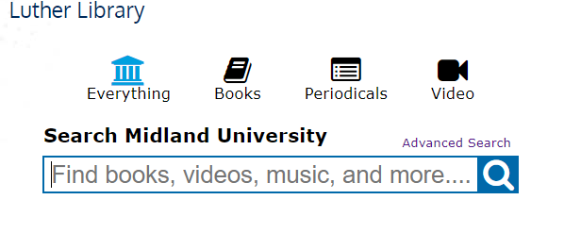
Click Search
If it is not held by Midland University, it will say Held by Area Libraries next to the material you are looking for
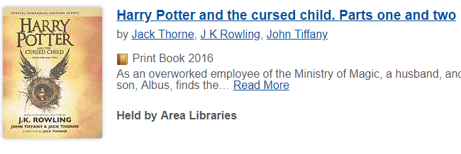

Click on the title of the book

A screen will pop up with information on the material you are looking for, the closest library that has the material, and the Request Item through Interlibrary Loan button.

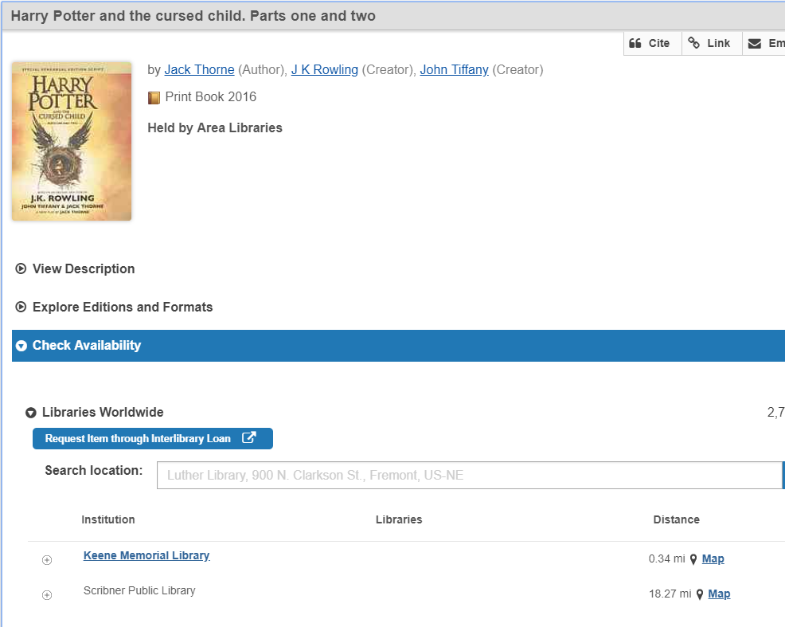

Click the Request Item through Interlibrary Loan button

A new screen will come up with highlighted fields that need to be filled out pertaining to the patron’s information
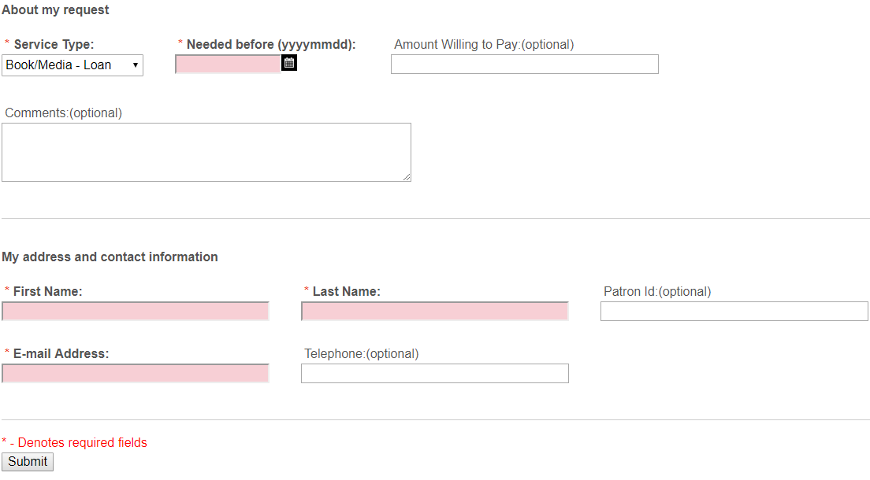

Click Submit after filling out the fields
You should get communication from the lending library about the status of your material requested

