New EBSCO Mobile App

- Go to your app store on your iPad (Can be downloaded for IOS and Android devices)
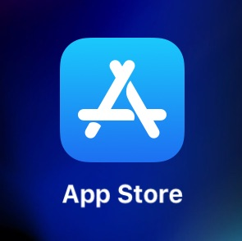

- Search for EBSCO Mobile and select “Get”

- Once downloaded, open the app. You should see this screen when the app opens. Click “Get Started”
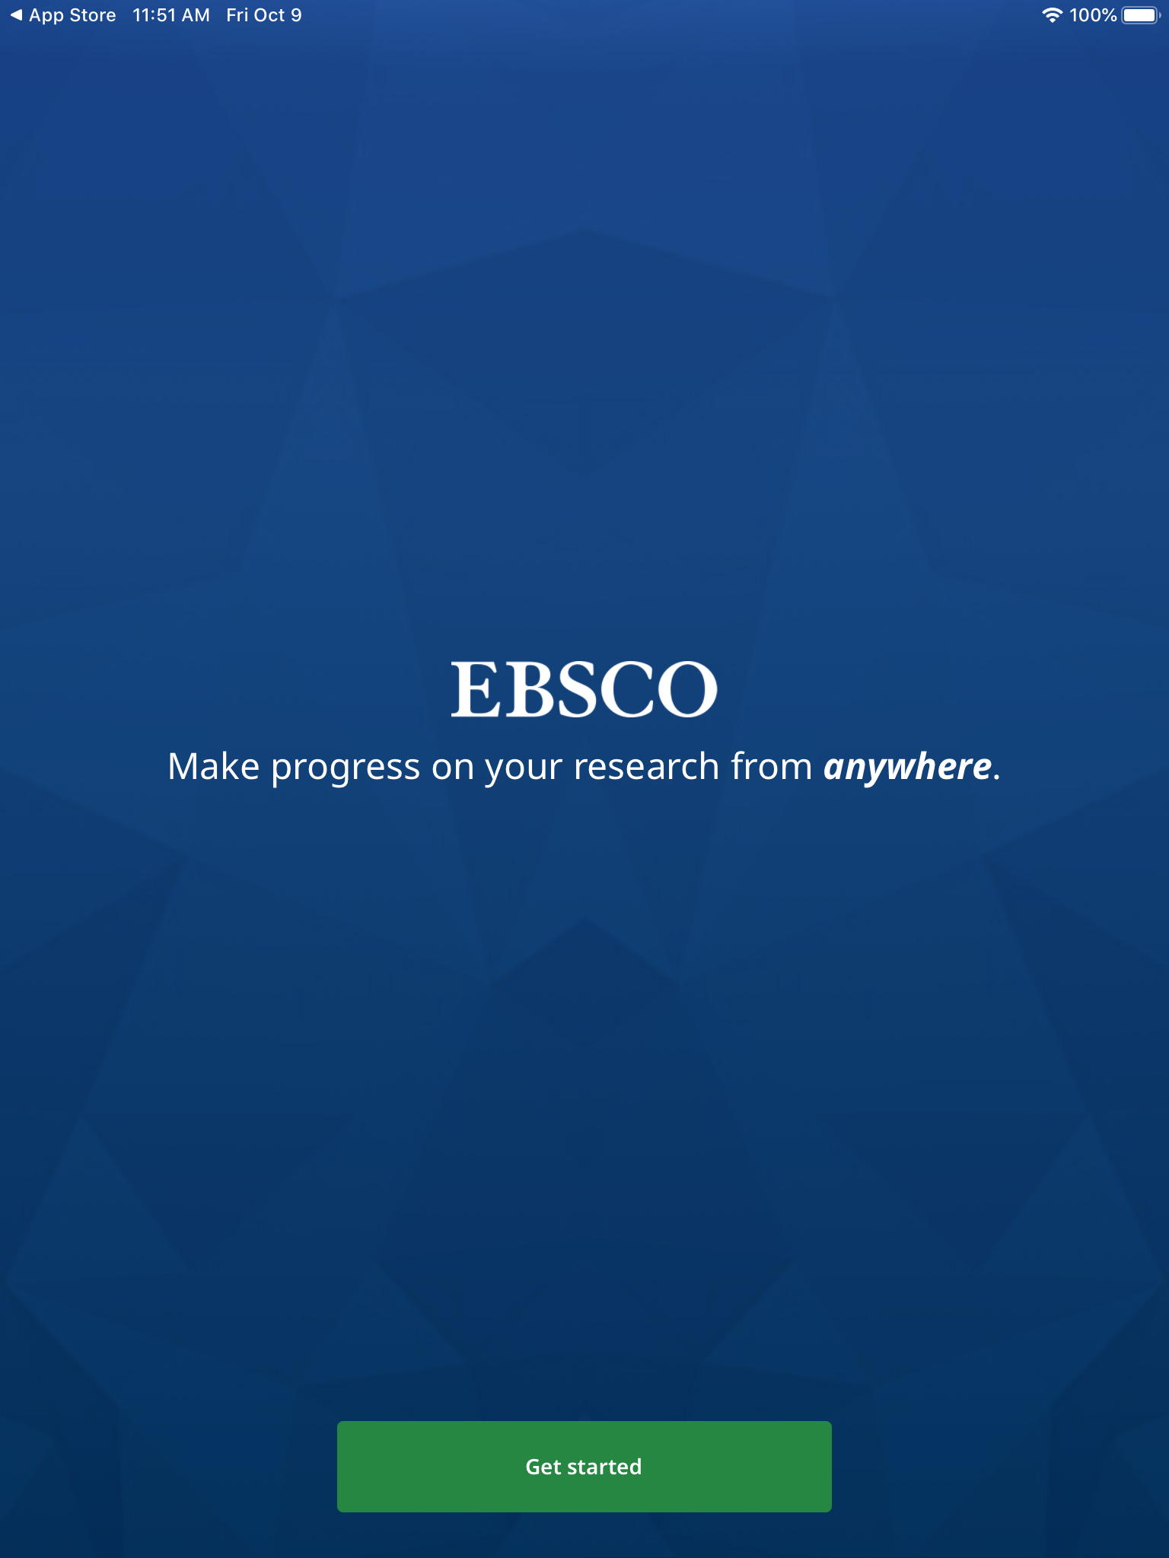

- Select “Use My Location” for the app to recognize Midland University. You can also search Midland University
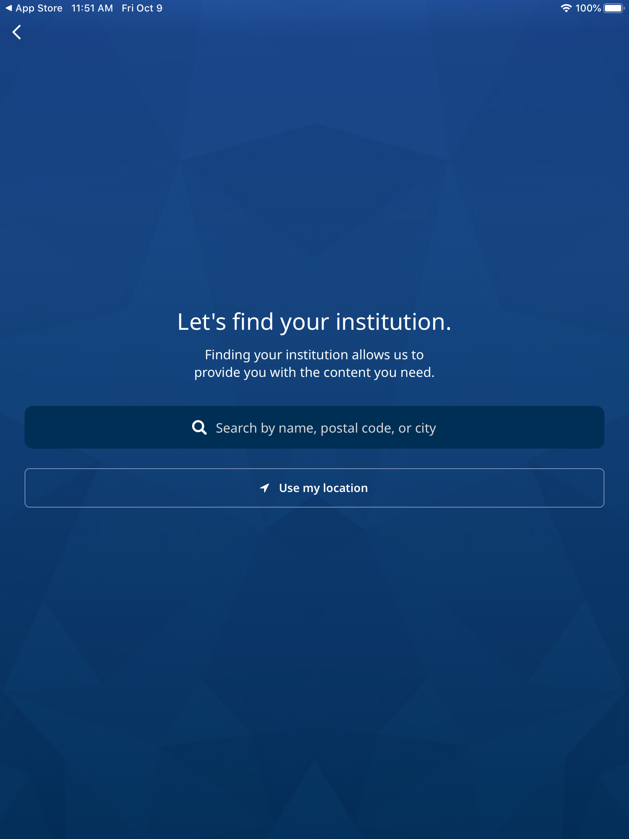
- Select Midland University
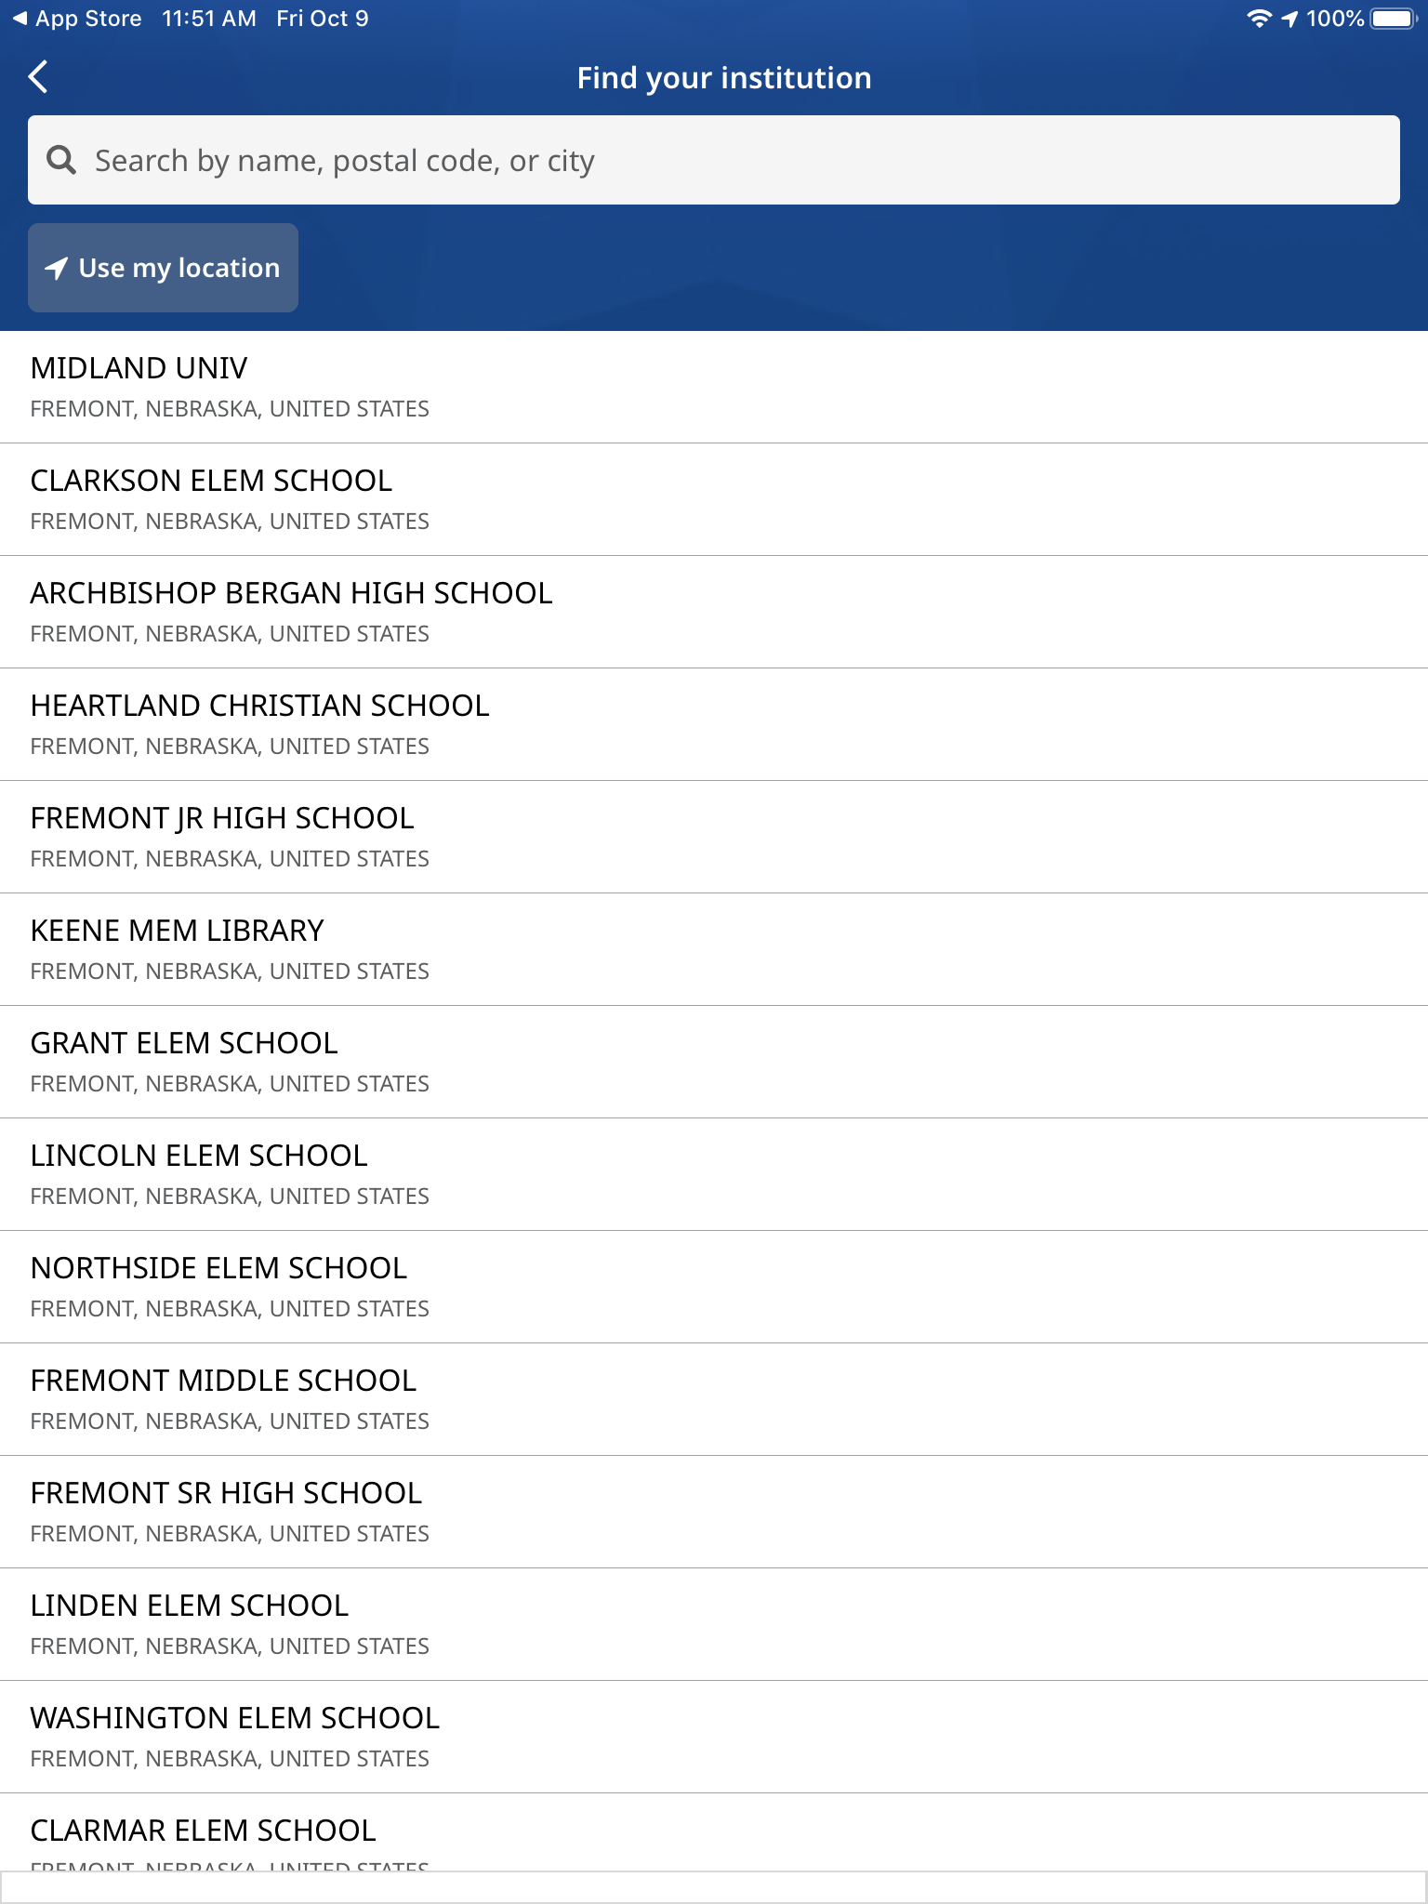

- Click “Connect Your Institution”
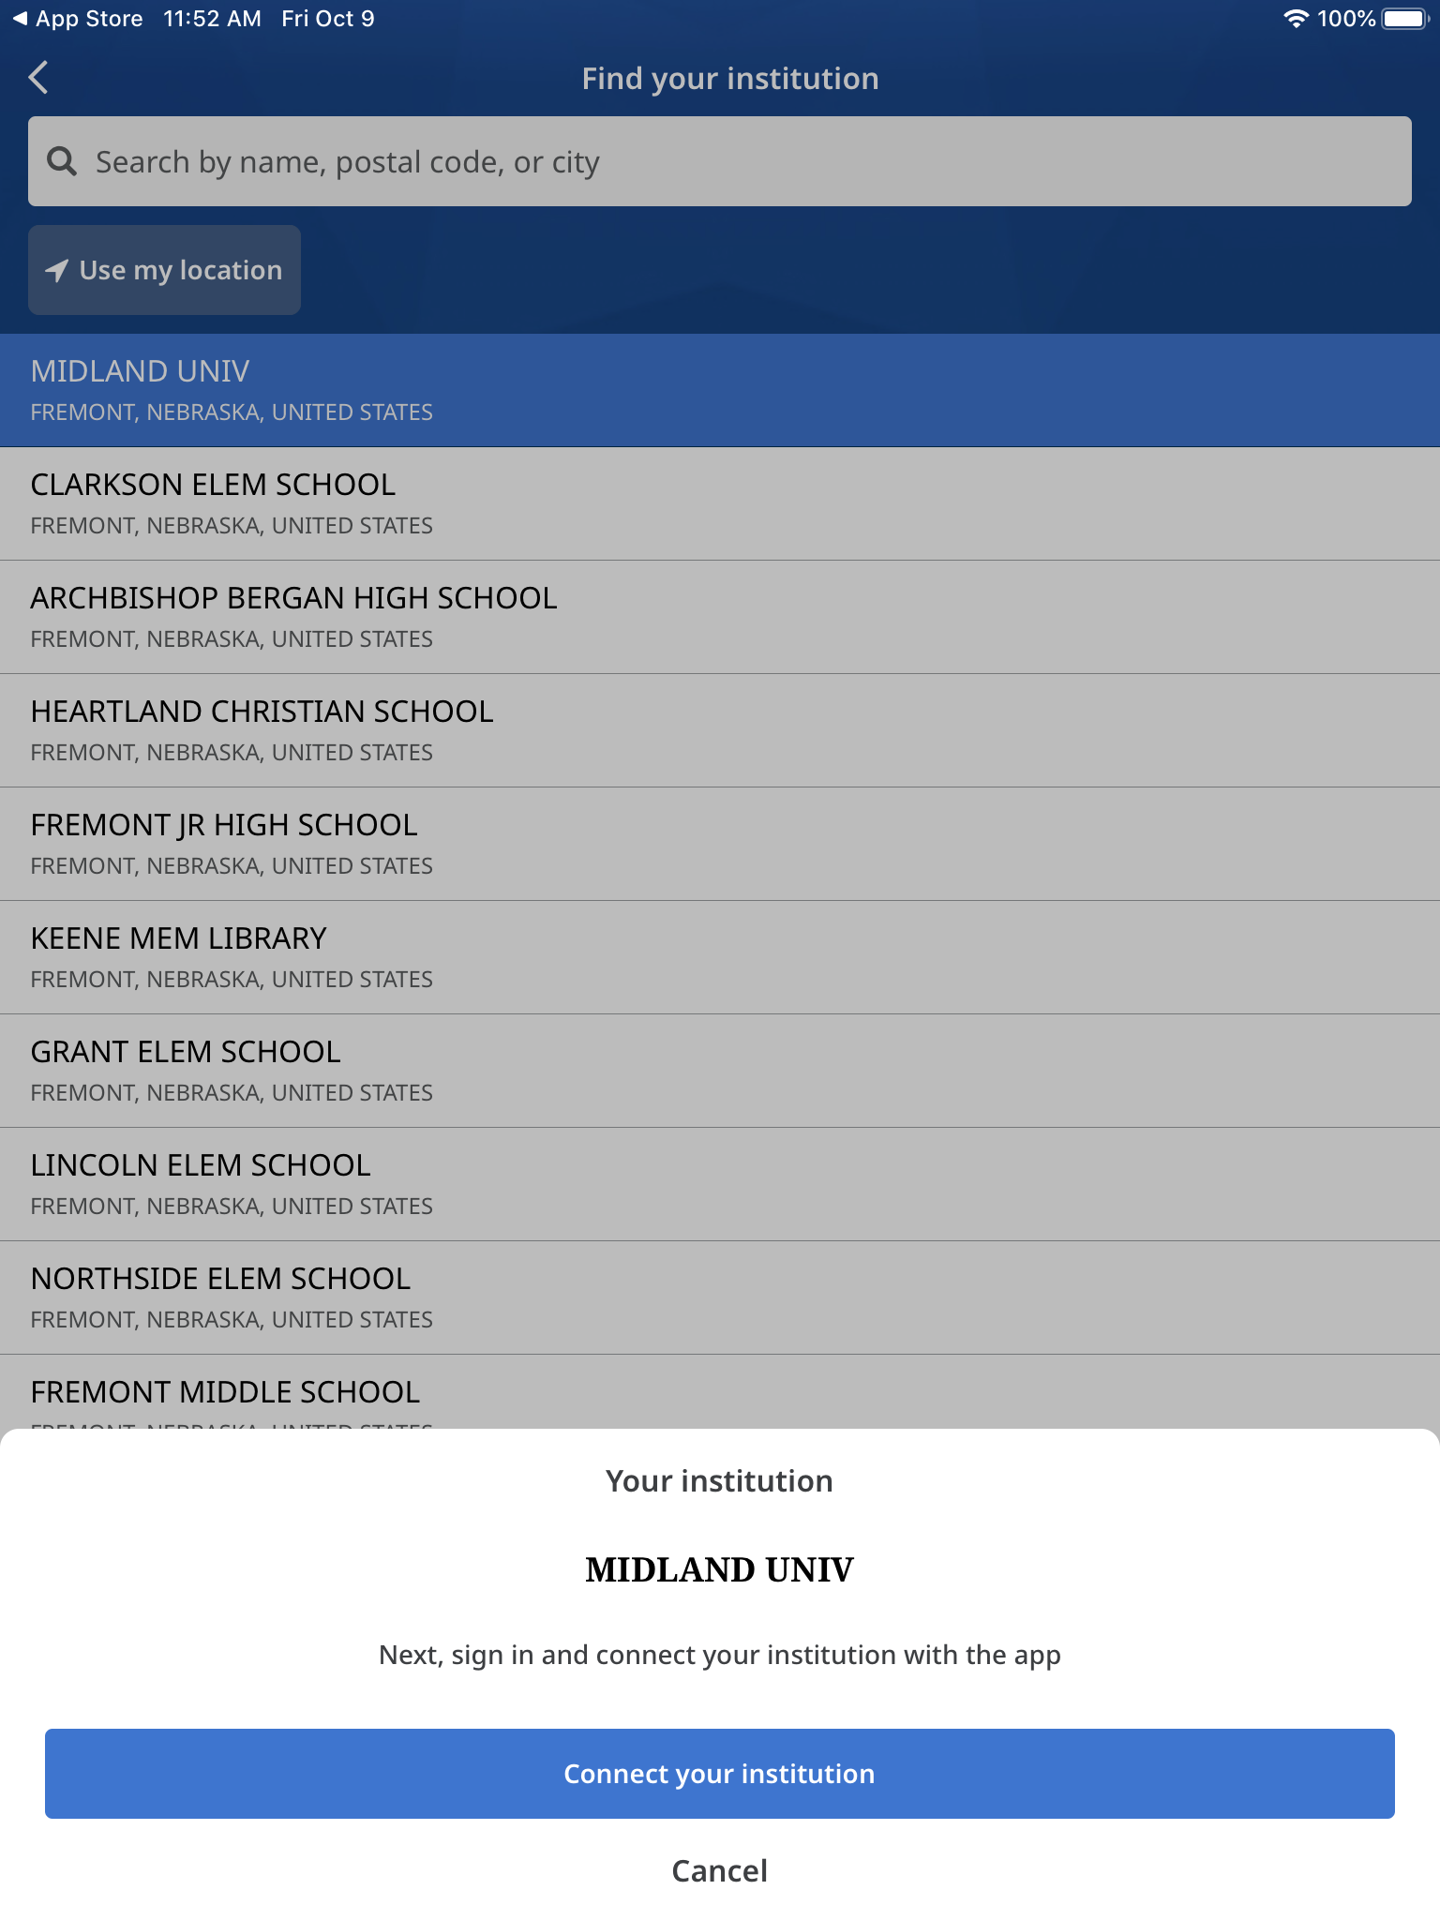
- EBSCO Mobile will want to use EBSCO.Zone to Sign In. Click Continue
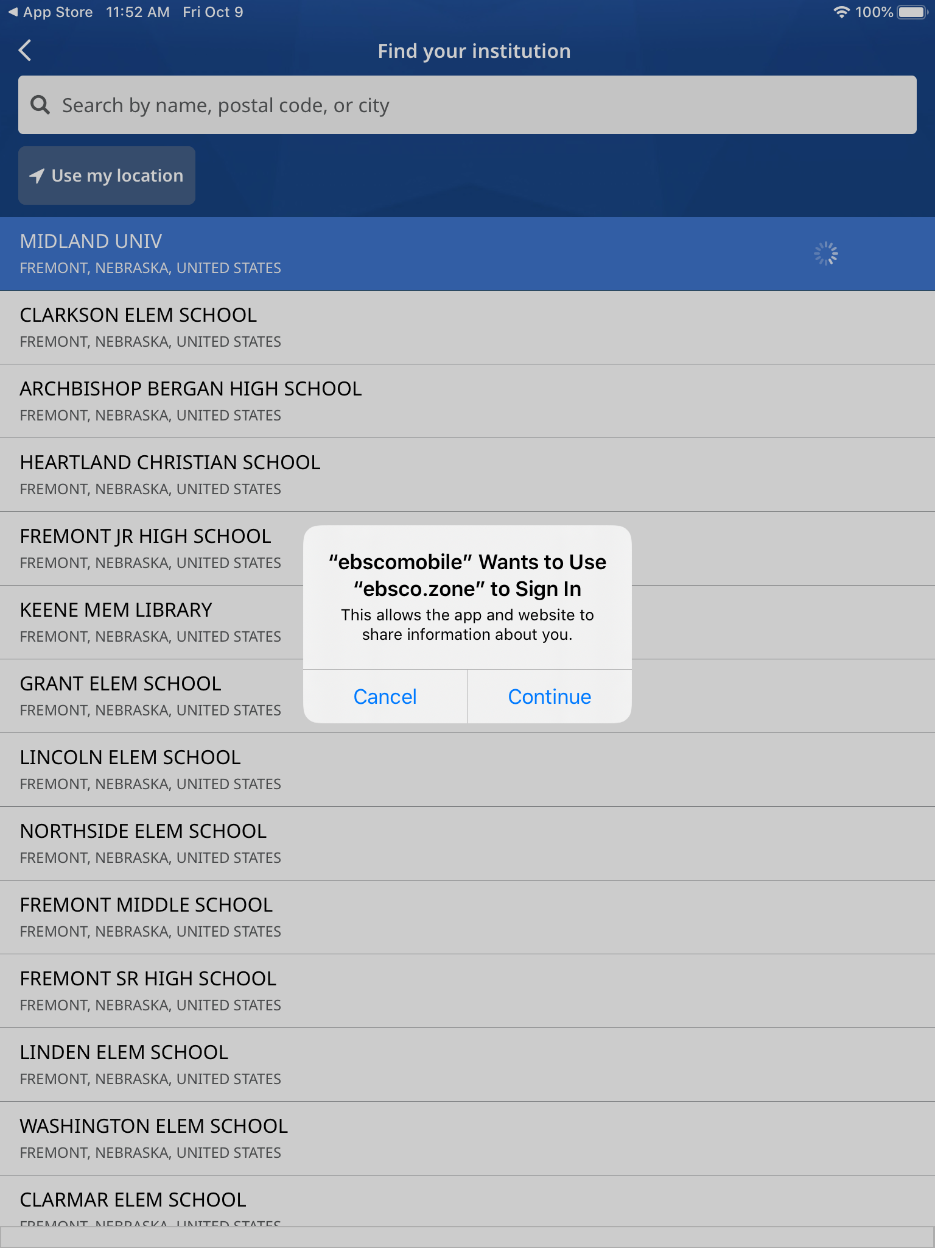

- You are now viewing EBSCO Mobile’s “Home Page.” To search, click on the magnifying glass at the bottom of the page
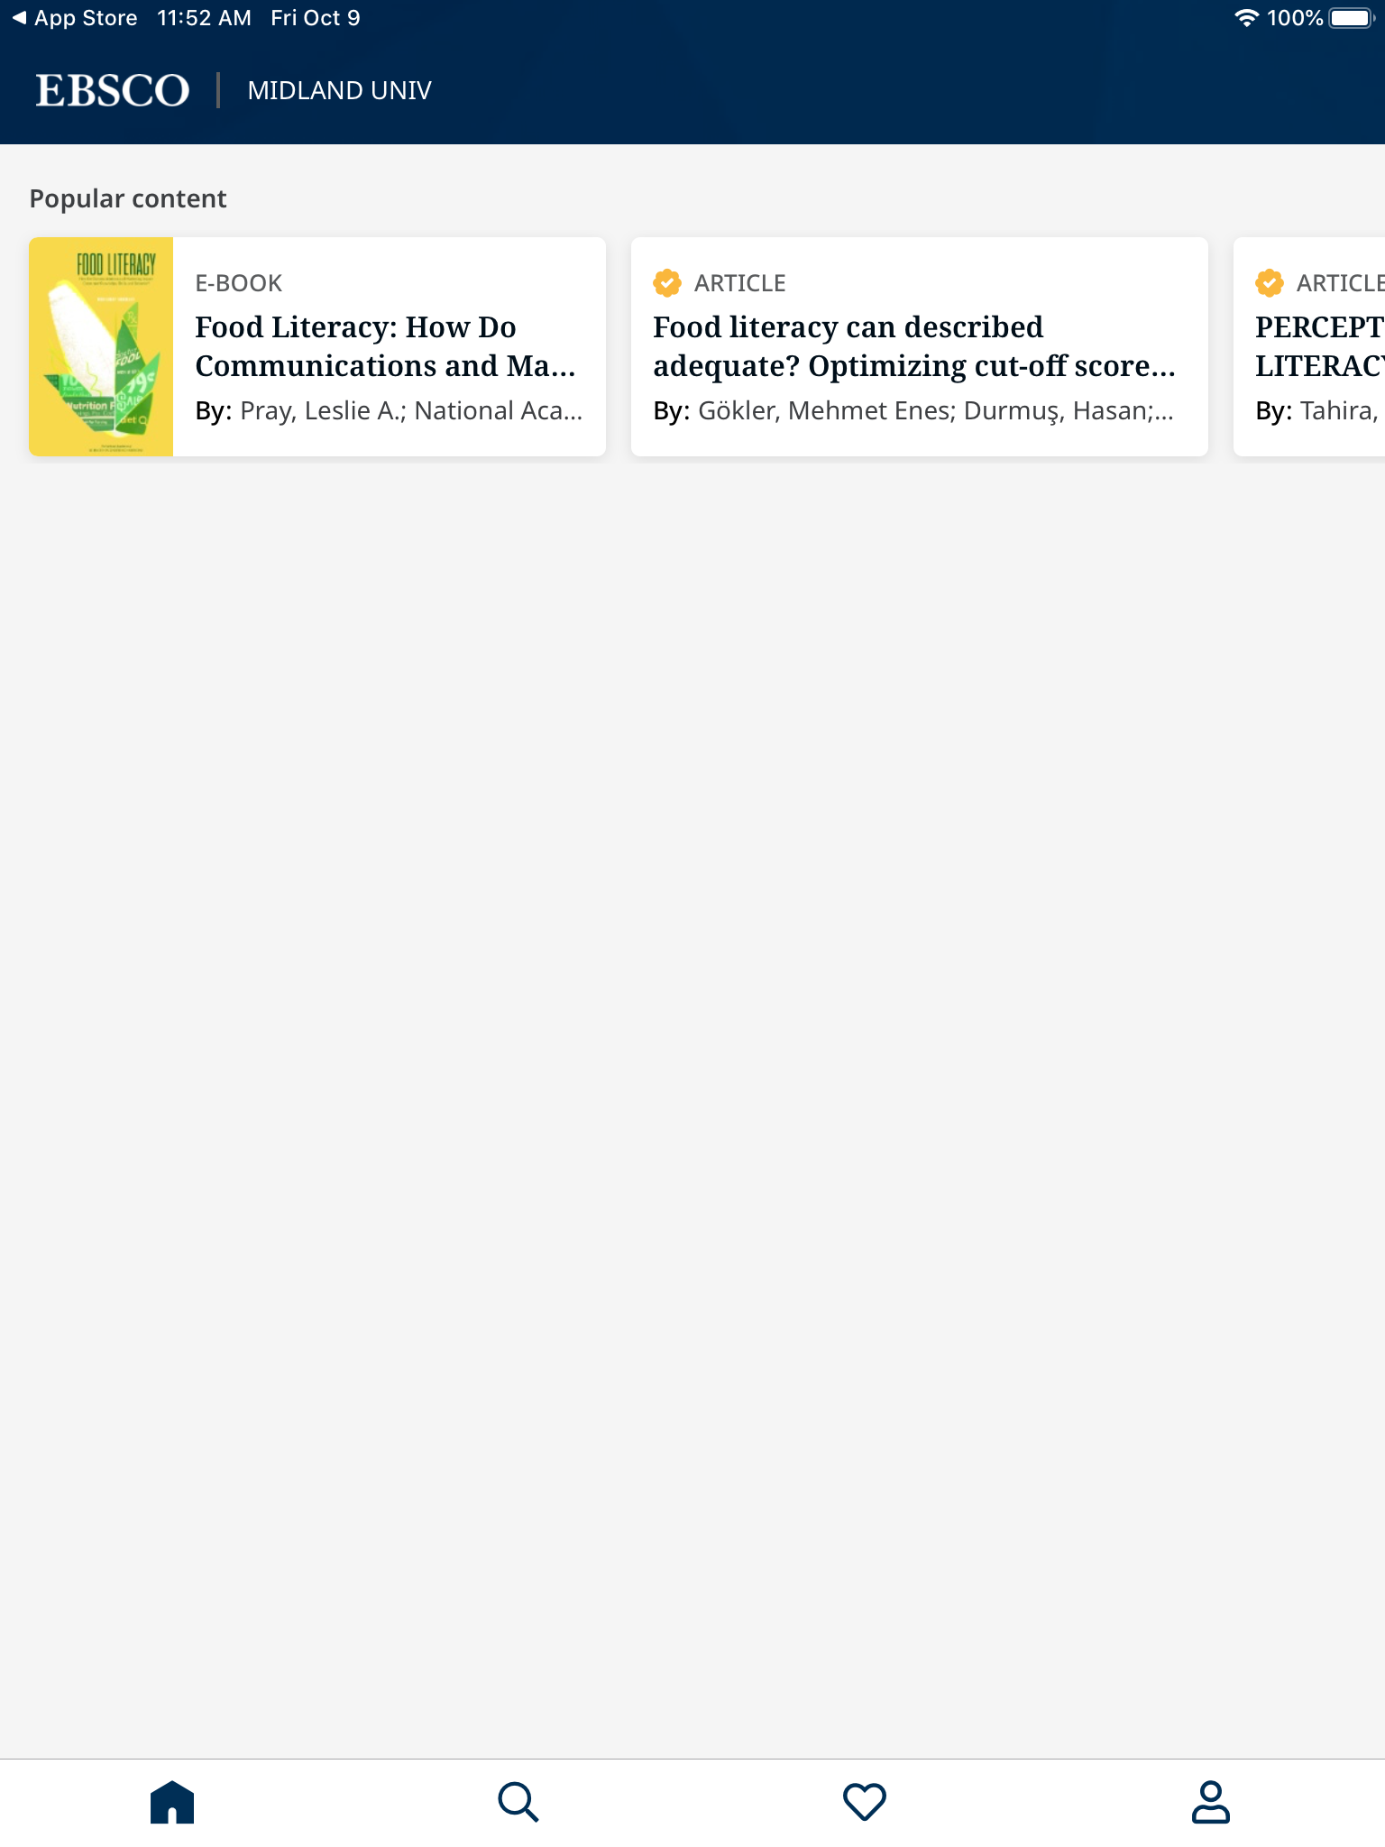

- You will now see the “Search” page. There are 3 limiters at the top of the page that you can limit your search to; Peer reviewed, Full text, and Publication date. Click on the ones you would like to activate. Begin searching for an article!
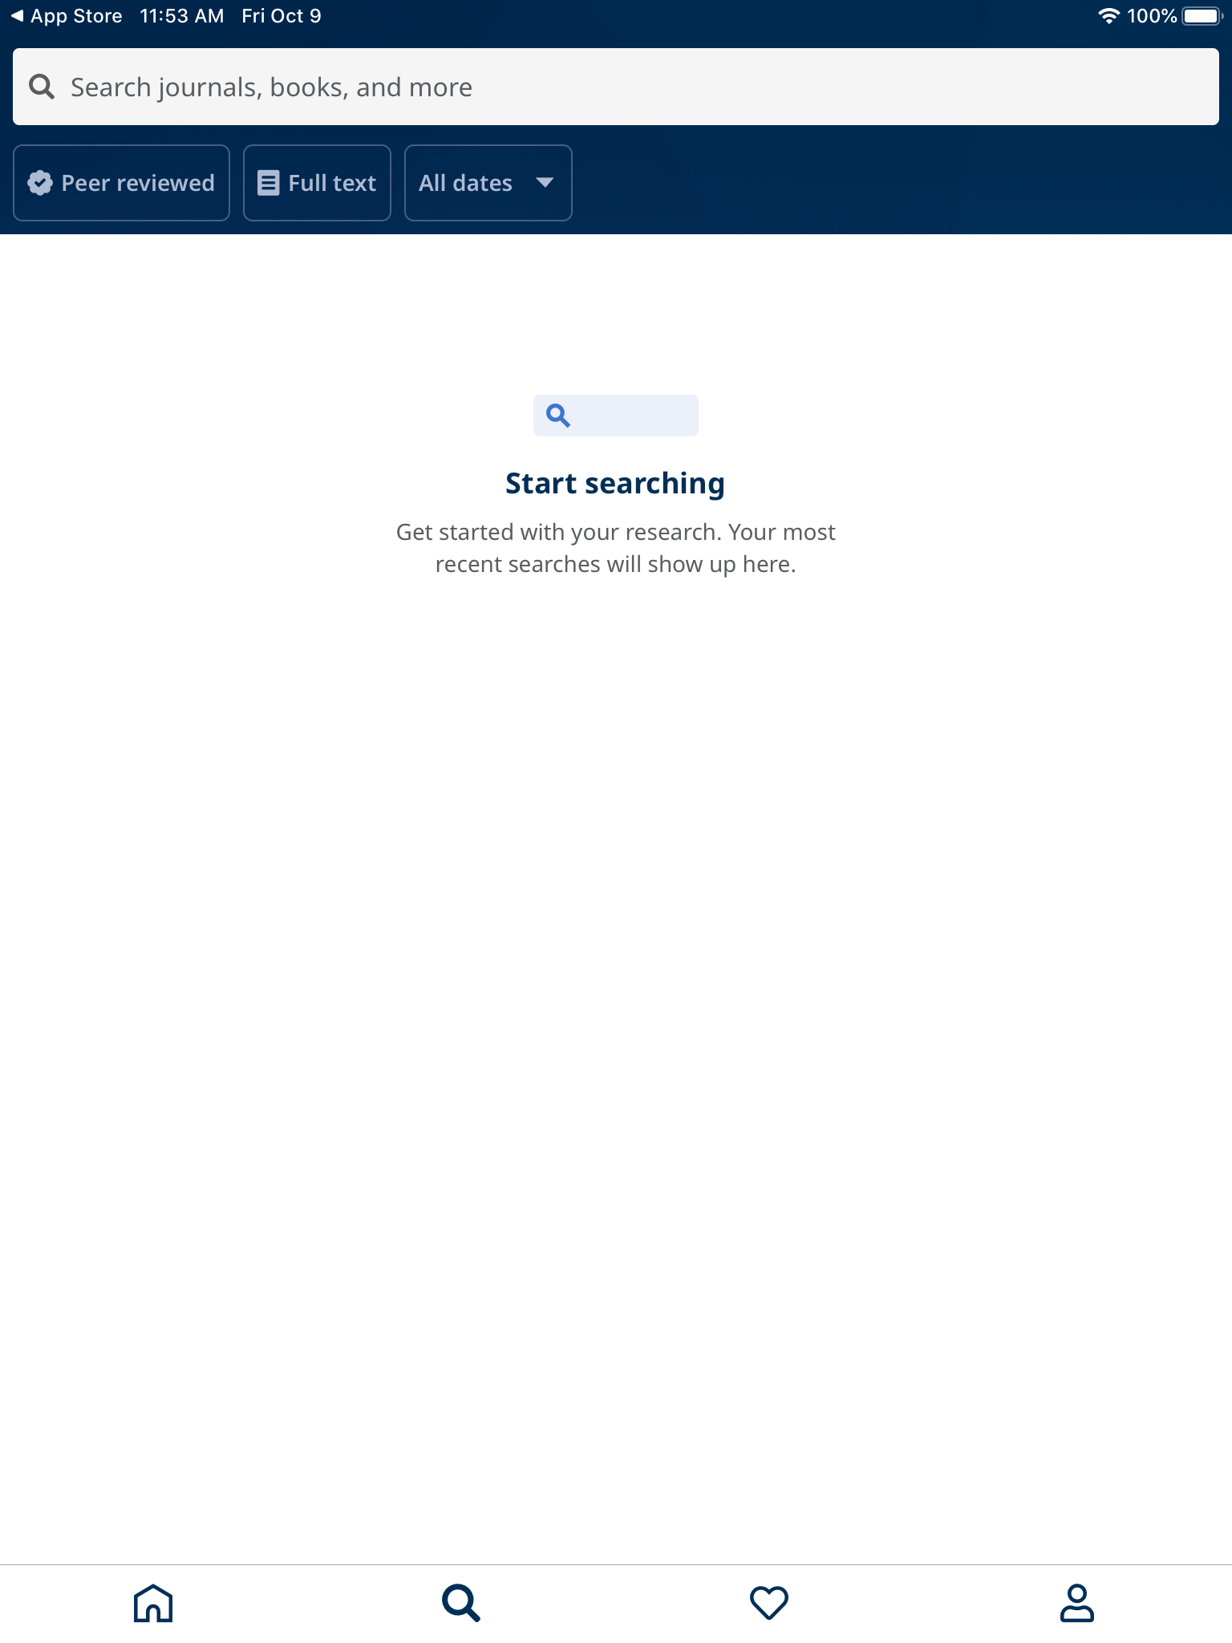

When you search, the app will be pulling articles from all of our EBSCO databases
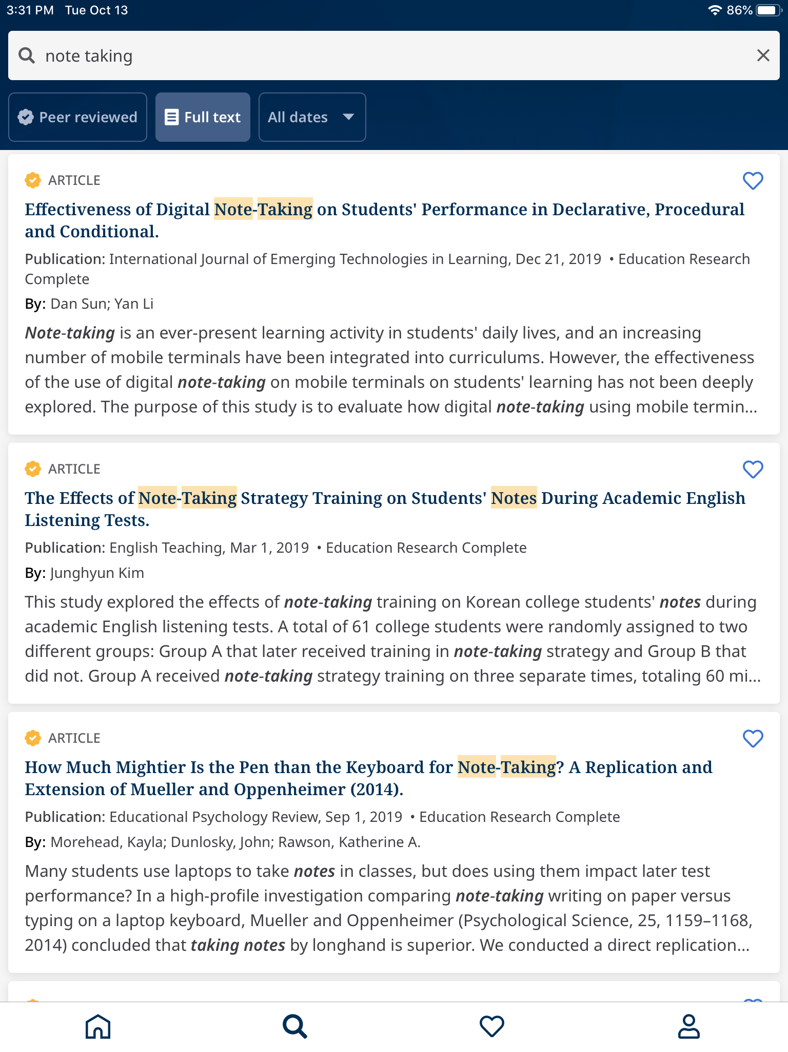

- Click on the article you like. Click “Read Now”
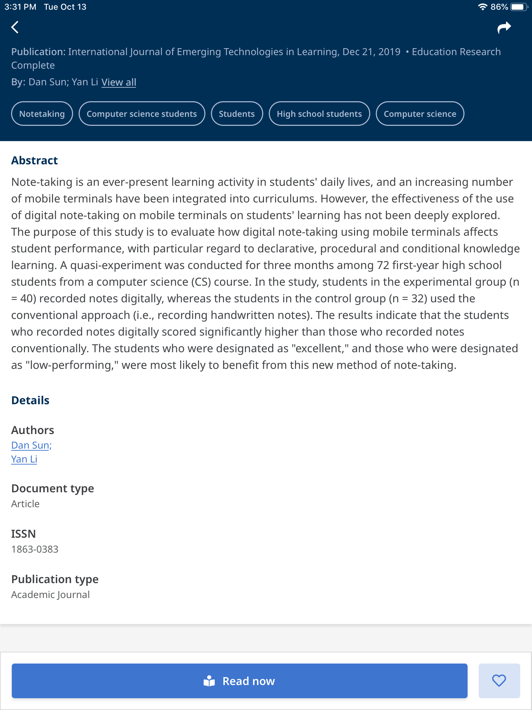

- You can select Read PDF or Listen (PDF)
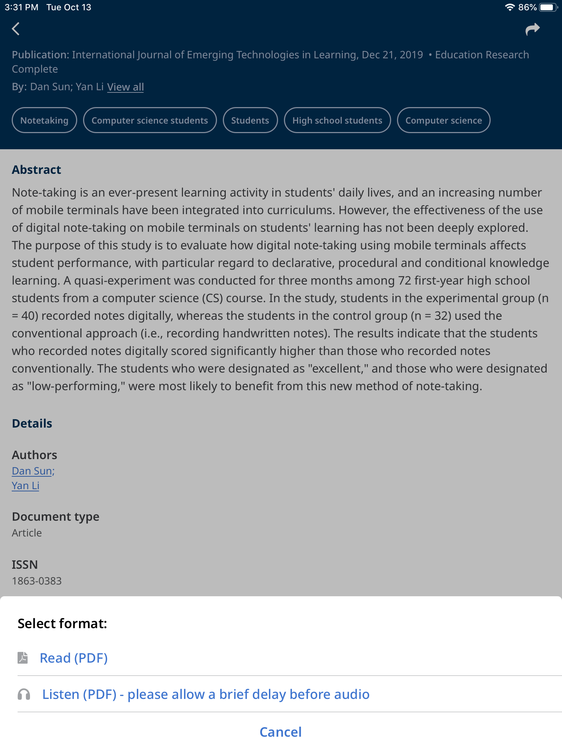

You can also “Love” articles that will be saved to your favorites. The “Love” or heart button will be on the right hand side of each article.
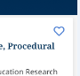

When you want to go through the articles that you marked as favorite, you can find the heart button at the bottom of the page.
After you click the heart button, you will be directed to your favorites
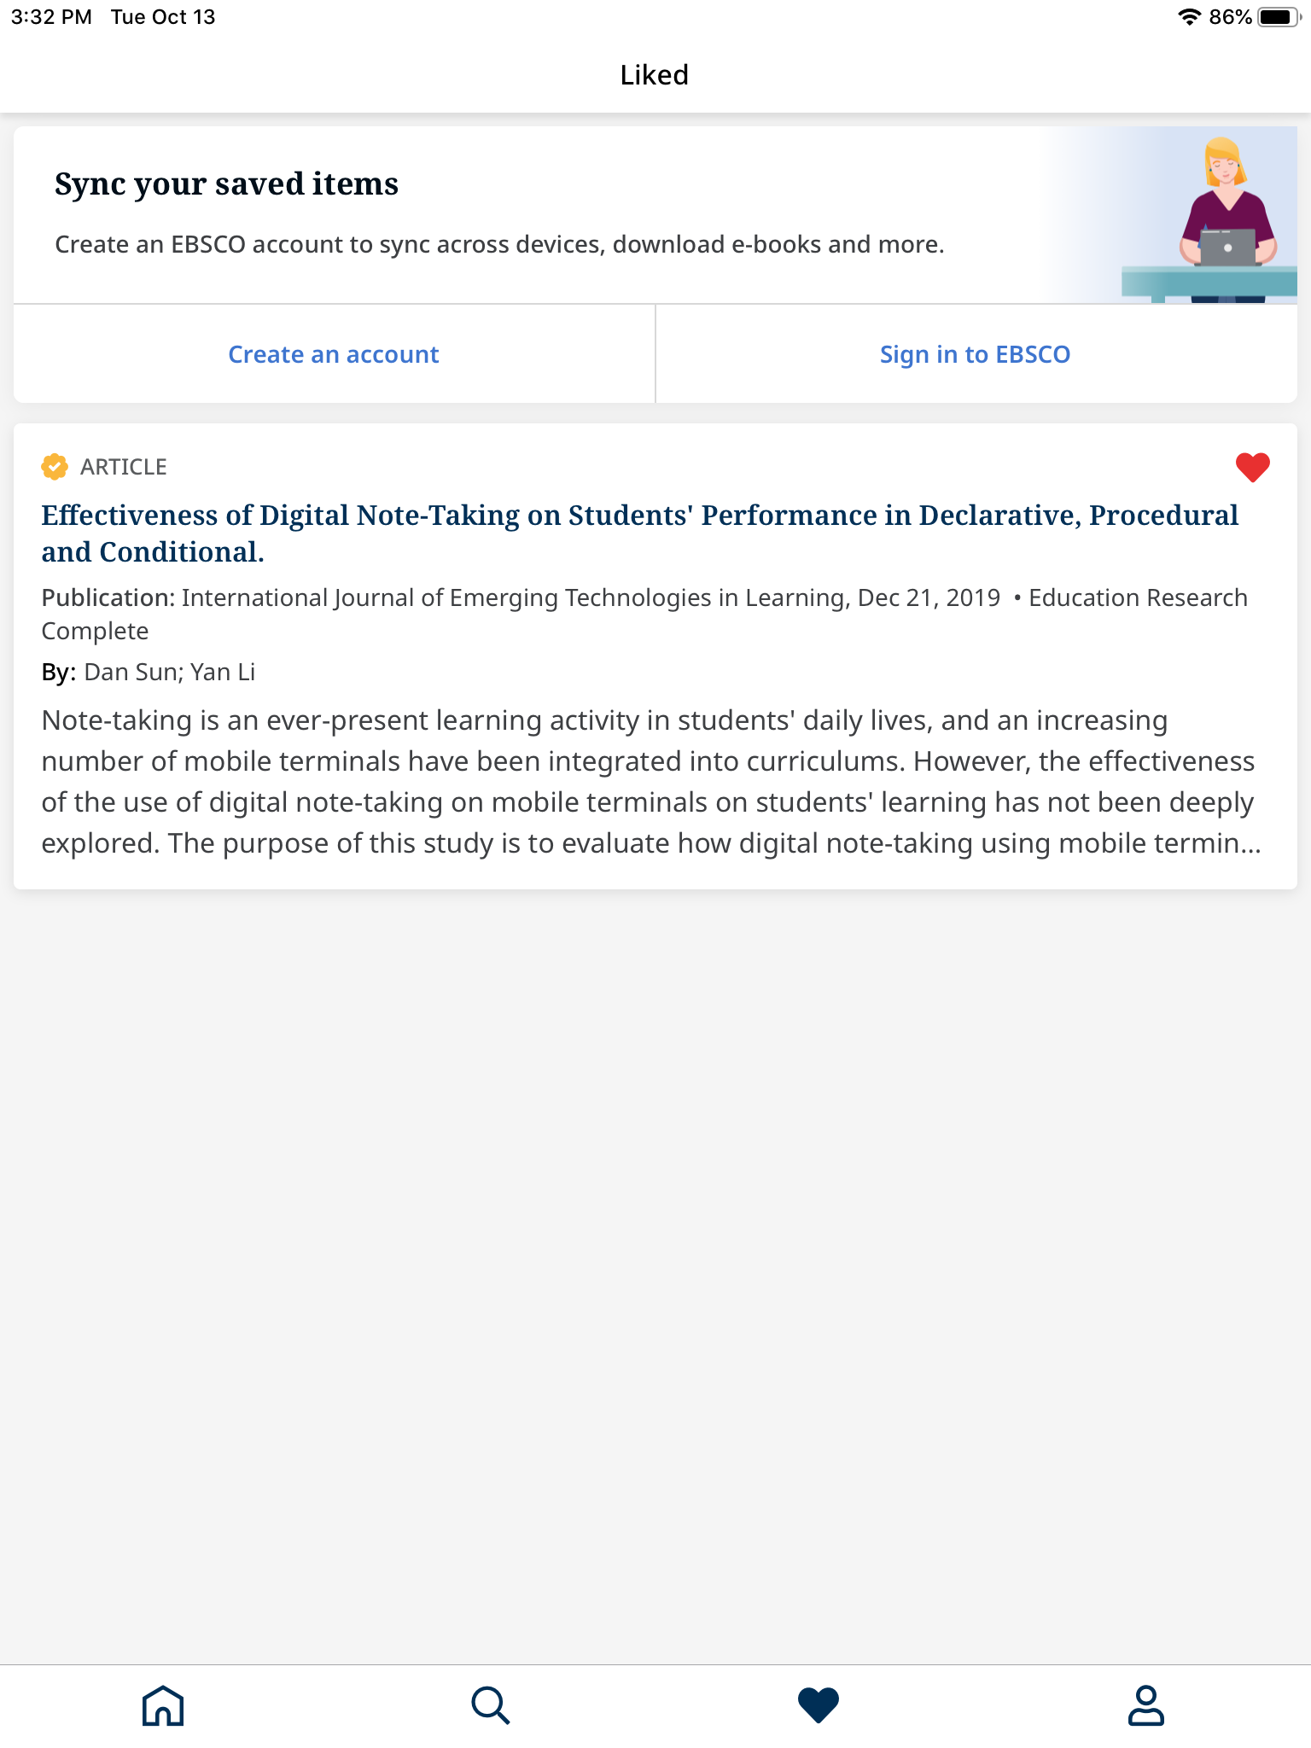

You also have the option to create an EBSCO account or sign in to your existing account to sync your “favorites” articles across all devices (computer, iPad, mobile) so you can browse those articles anytime on another device
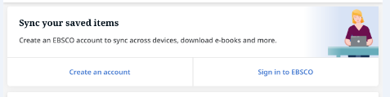

Any questions? Contact Head Librarian, Laura Hinman at hinmanl@midlandu.edu

